**SALT**

**HERO**



Salt is a widely used material across industries including food processing, chemical manufacturing, and water treatment. Flexicon bulk material handling equipment is designed to move, store, and process salt efficiently while minimizing wear and contamination..

**Button**: Talk To Us

**SHELF #1 - PRODUCT DESCRIPTION**

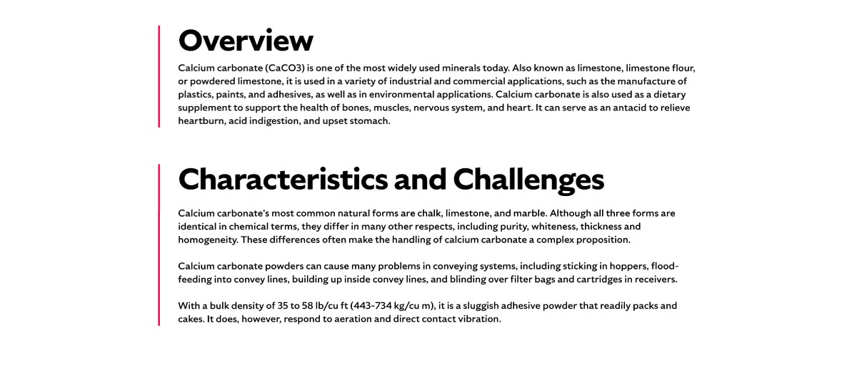

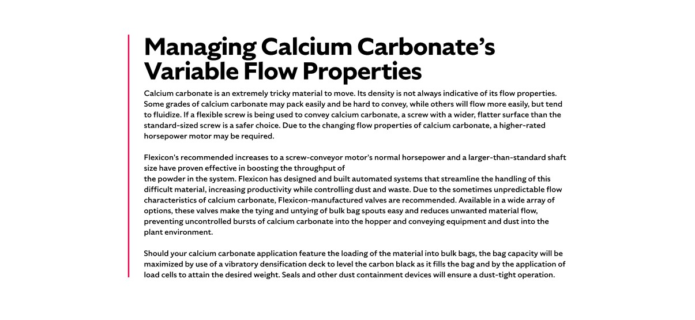

**Overview**Salt, primarily composed of sodium chloride, is available in refined and unrefined forms and serves a broad range of industrial and commercial applications. Beyond its role in food production, salt is used in textiles, detergents, water softening, and as a de-icing agent for roads. Its versatility and commercial value make it a staple in manufacturing processes worldwide. Whether used in chemical processing or infrastructure maintenance, salt delivers consistent performance and utility.

**Characteristics and Challenges**Salt is typically free-flowing and crystalline, available in granular, rock, or micronized forms. Its hygroscopic nature means it absorbs moisture from the air, which can lead to clumping and flow issues. To maintain consistent flow, flow agents may be added, and equipment must be built to withstand salt’s abrasive and corrosive properties. Pneumatic conveying systems require properly sized blowers and may need moisture control devices to prevent clogs and degradation of salt granules. For corrosion resistance, 316L stainless steel is often recommended.

When salt arrives in bulk bags, discharge frames may need accessories depending on the salt grade and packaging quality. Flexible screw conveyors with round-profile screws are commonly used to handle salt’s granular form. Hopper geometry is critical to avoid charging errors, and devices like vibrators or agitators may be needed to promote flow. For manual dumping, hopper screens help prevent foreign material entry and protect operators from moving parts.

**SHELF #2 - FLEXICON SOLUTIONS**

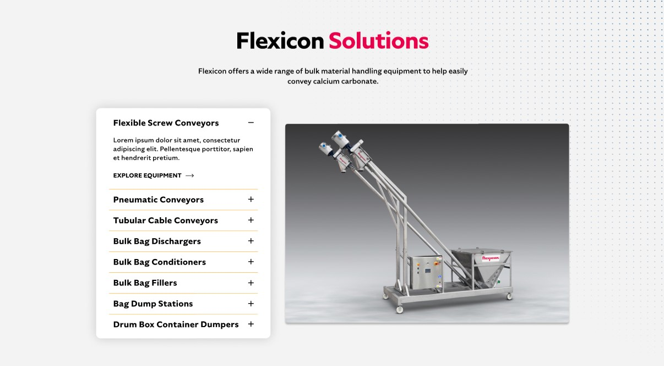

**Flexicon Solutions**

Flexicon offers a wide range of bulk material handling equipment to help easily convey salt.

**Flexible Screw Conveyors:** Built to handle salt’s abrasive texture, these conveyors maintain consistent flow with durable, corrosion-resistant screws.

**Pneumatic Conveyors:** These enclosed systems gently transport salt while protecting it from moisture and minimizing dust emissions.

**Tubular Cable Conveyors**: Ideal for confined spaces, these conveyors offer sealed transport paths that preserve salt purity and prevent contamination.

**Bulk Bag Dischargers:** Designed for complete emptying, these systems feature mechanisms that stretch and activate bulk bags to release all salt contents efficiently.

**Bulk Bag Conditioners:** Restore flowability by breaking up hardened salt inside bulk bags, ensuring smooth discharge into downstream equipment.

**Bulk Bag Fillers:** Deliver precise filling of salt into bulk bags using vibration decks and weight controls, while keeping operations clean and dust-free.

**Bag Dump Stations:** Provide a safe and ergonomic solution for manually adding salt to your process, with integrated filtration to control airborne particles.

**Drum/Box/Container Dumpers:** Enable efficient transfer of salt from smaller containers into processing systems, reducing manual labor and dust exposure.

**SHELF #3: LIFETIME PERFORMANCE GUARANTEE**

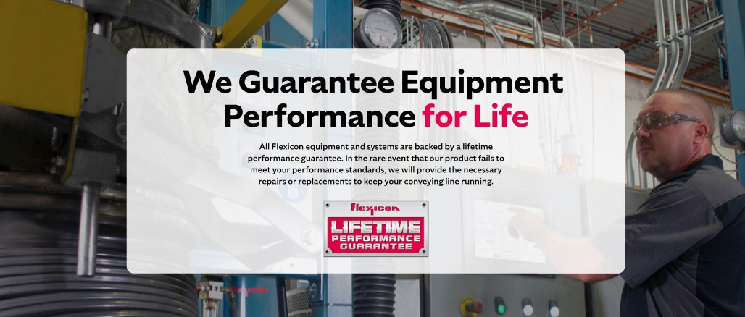

**Lifetime Performance Guarantee**

All Flexicon equipment and systems are backed by a lifetime performance guarantee. In the rare event that our product fails to meet your performance standards, we will provide the necessary repairs or replacements to keep your conveying line running.

**SHELF #4: CASE STUDIES**



A very versatile compound, salt has multiple applications in the food, chemical and construction industries.